Black skin with golden text

ANTECEDENTS OF THE INDIVIDUAL’S SUPPORT FOR CHANGE: A PROPOSED MODEL WITH AN EMPIRICAL EVIDENCE

By

KAMRAN KHAN
(0000000)

Supervisor
Dr. Bakhtiar Ali



Shaheed Zulfikar Ali Bhutto Institute of Science and Technology

(SZABIST), Islamabad

February, 2012
Antecedents of the individual’s support for change: a proposed model with empirical evidence

By

KAMRAN KHAN
(000000)

A THESIS SUBMITTED IN PARTIAL FULFILLMENT OF THE REQUIREMENT FOR THE DEGREE OF
MASTER OF SCIENCE
IN MANAGEMENT SCIENCES
TO
DEPARTMENT OF MANAGEMENT SCIENCES

Shaheed Zulfikar Ali Bhutto Institute of Science and Technology

(SZABIST), Islamabad

February, 2012


DISSERTATION AND DEFENSE APPROVAL FORM
The undersigned certify that they have read the following thesis, examined the defense, are satisfied with the overall exam performance and recommend the thesis to the Department of Management Sciences SZABIST for acceptance:

Dissertation Title: Antecedents of the individual’s support for change: a proposed model with an empirical evidence
Submitted by: Kamran khan Registration # 00000000
Master of Science
Department of Management Sciences

Dr. Aaaaaaaaaaaaaaaaa _
Name of the research supervisor Signature of the research supervisor

Dr. Muhammad Asif Khan _
Name of the Program Manager Signature of the Program Manager

Dr. Muhammad Asif Khan _
Name of the Head of Department Signature of the Head of Department

Khusro Pervaiz Khan _
Name of the HOC Signature of the HOC

CANDIDATE DECLARATION FORM

I, Kamran khan S/O of Muhammad Iqbal, Registration # 000000, a candidate of Master of science (Management Sciences) at Shaheed Zulfikar Ali Bhutto Institute of Science and Technology, Islamabad do hereby declare that the Thesis Antecedents of the individual’s support for change: a proposed model with an empirical evidence submitted by me in partial fulfillment of MS degree is my original work, and this work contains no material which has been previously accepted for the award of any degree or qualification in any institution and, to the best of my knowledge and belief, contains no material published by another party, except where due reference is made in the text.

_
Signature
21.02.2012
Date Kamran Khan
Name

DEDICATION

I dedicate this thesis to my parents and siblings who always encourage me to prosper in life and career.

ACKNOWLEDGEMENTS

All praise is to Allah, the most passionate and the merciful. There is just too much of His blessing in this life to count. Peace and blessings be on His Prophet.
I would like to thank everyone who helped me out during the time. First and foremost, I want to say thank to my family. I am indebted to express my deep gratitude to my parents and siblings. They always showed an interest in what I was doing, and invariably showed patience and understanding when my time at home was filled with research work-related activities instead of family time. Without their kind support, encouragement and dedication, this thesis would not have been fully realized. And my little naughty niece and nephews can never be ignored; whose mischievous yet innocent smile always refreshed me during my work.
I am indebted to my Supervisor, Dr. Bakhtiar Ali. I really appreciate his sound academic support and the ability to let me see “the bigger picture”. Most importantly, thanks for setting high standards that drove me to work harder in order to attain my goals. He always encouraged me to “go the extra mile”.

ABSTRACT

The present research proposed and empirically tested antecedents of the individual’s support for change. To examine sixteen posited relationships of the proposed framework, data were collected from two independent data sets including 350 university students (Study I) and 507 employees (Study II) of telecommunication organizations of Pakistan. For both studies, structural equation modeling technique was employed for data analyses. Study I demonstrated that only one antecedent (creativity) was significantly associated with support for change. Study II exhibited that all the four antecedents (emotional intelligence, creativity, transformational leadership perceptions and change commitment) were significantly associated with support for change. The research also examined the moderating effects of dissatisfaction with status quo on all the posited relationships of the model. The results revealed that dissatisfaction with status quo could not moderate any posited relationships in study I. However, in study II three relationships were moderated by this variable. The results of the present research can be useful to impart training among employees so that individual’s support for change can be attained. The findings of the present research also have implications for academia in preparing and training of the future managers (students). Cross sectional design of the study is one of the limitations of the present research. Further, the present study examined each variable as one-dimensional. The study empirically tested the proposed model on the basis of data elicited from a single source (only employees and students). It is suggested that the present study may be replicated by removing these limitations in other cultures and organizations.

TABLE OF CONTENTS

DEDICATION v
ACKNOWLEDGEMENTS vi
ABSTRACT viii
TABLE OF CONTENTS ix
LIST OF TABLES xiii
LIST OF FIGURES xiv
LIST OF ABBREVIATIONS xv
1. INTRODUCTION 1
1.1 BACKGROUND 1
1.2 RATIONALE OF THE STUDY 6
1.3 THE CONTEXT OF THE STUDY 8
1.4 LITERATURE GAP PERTAINING TO THE TOPIC OF STUDY 10
1.5 RESEARCH OBJECTIVES 10
1.6 RESEARCH QUESTIONS 11
1.7 SCOPE OF THE STUDY 12
1.8 DELIMITATIONS OF THE STUDY 12
1.9 ORGANIZATION OF THE STUDY 14
2. LITERATURE REVIEW 15
2.1 THEORETICAL REFLECTIONS 17
2.1.1 Intentional Change Theory 17
2.2 CONCEPTS AND DEFINITIONS 19
2.2.1 Change: Types, Reactions and Consequences 19
2.2.2 Effective Change Management 22
2.2.3 Resistance to Change 23
2.2.4 Readiness for Change 25
2.2.5 Support for Change 25
2.2.6 Administrating Support for Change – A Better Choice 27
2.3 ANTECEDENTS OF THE INDIVIDUAL’S SUPPORT FOR CHANGE 29
2.3.1 Emotional Intelligence 29
2.3.2 Transformational Leadership Perceptions 34
2.3.3 Change Commitment 36
2.3.4 Creativity 40
2.3.5 Dissatisfaction with Status Quo 43
2.4 POSITED RELATIONSHIPS AMONG STUDY VARIABLES 46
2.4.1 Emotional Intelligence and Support for Change 46
2.4.2 Emotional Intelligence and Transformational Leadership Perceptions 47
2.4.3 Emotional Intelligence and Change Commitment 48
2.4.4 Change Commitment and Support for Change 48
2.4.5 Change Commitment and Creativity 49
2.4.6 Transformational Leadership Perceptions and Creativity 50
2.4.7 Transformational Leadership Perceptions and Support for Change 51
2.4.8 Creativity and Support for Change 52
2.4.9 The Moderating Effects of Dissatisfaction with Status Quo 53
3. RESEARCH METHODOLOGY 56
3.1 THEORETICAL FRAMEWORK 57
3.2 DEFINITIONS OF THE TERMS 58
3.3 POSITED RELATIONSHIPS 64
3.4 HYPOTHESES 64
3.5 RESEARCH DESIGN 65
3.6 PARTICIPANTS AND PROCEDURES 67
3.6.1 Sample I – Students Data Set 67
3.6.2 Sample II – Field Data Set 68
3.7 MEASURES 74
3.7.1 Support for Change 74
3.7.2 Emotional Intelligence 75
3.7.3 Change Commitment 75
3.7.4 Creativity 75
3.7.5 Transformational Leadership Perceptions 75
3.7.6 Dissatisfaction with Status Quo 76
3.8 RELIABILITY AND VALIDITY 76
3.8.1 Translation Validity – Content and Face 76
3.8.2 Inter-item Consistency 78
3.8.3 Composite Reliability 78
3.8.4 Construct Validity – Convergent and Divergent 78
3.9 DESCRIPTIVE STATISTICS AND CORRELATION ANALYSIS 79
3.10. DATA ANALYSIS APPROACH 91
3.10.1 Structural Equation Modelling 91
3.10.2 Model Fitness 92
3.10.3 Moderation Analysis 93
3.10.4 Preliminary Data Analysis 94
4. RESULTS 96
4.1 STUDY I: UNIVERSITY DATA 98
4.1.1 Measurement Model (Baseline Model) 98
4.1.2 Structural Model (Baseline Model) 98
4.1.3 Moderating Effects of DSQ 102
4.2 STUDY II: FIELD DATA 109
4.2.1 Measurement Model (Baseline Model) 109
4.2.2 Structural Model (Baseline Model) 109
4.2.3 Moderating Effects of DSQ 112
5. DISCUSSION, CONCLUSION, AND RECOMMENDATIONS 118
5.1 DISCUSSION 118
5.2 CONCLUSION 128
5.3 RECOMMENDATIONS 130
5.3.1 Managerial Implications 130
5.3.2 Theoretical Implications 132
5.4 LIMITATIONS AND RECOMMENDATIONS FOR FUTURE RESEARCH 133
REFERENCES 135
APPENDICIES 166
Urdu Survey Questionnaire. 166
English Survey Questionnaire. 171
LIST OF APPENDICES

Appendix A | Survey Questionnaire (Urdu) | 166
Appendix B | Survey Questionnaire (English) | 170

LIST OF TABLES
Table No | TABLE DESCRIPTIONS | Page #
Table 1 | Population proportion……………………………………………………. | 70
Table 2 | Sample Characteristics ………………………………………………… | 72
Table 3 | Inter-item Consistency, Composite Reliability, Convergent Validity and Discriminant Validity - Study I………………………………………… | 80
Table 4 | Descriptive Statistics and Correlation - Study I…………………………. | 83
Table 5 | Inter-item Consistency, Composite Reliability, Convergent Validity and Discriminant Validity -Study II……………………………………….. | 85
Table 6 | Descriptive Statistics and Correlation – Study II………………………… | 88
Table 7 | Model Fitness Indices - Study I………………………………………….. | 99
Table 8 | Results of Hypotheses - Study I………………………………………….. | 101
Table 9 | Pair Wise Parameter Comparisons – Study I……..………………………. | 106
Table 10 | Results of Moderation Hypotheses - Study I…………………………… | 107
Table 11 | Model Fitness Indices - Study II………………………………………… | 110
Table 12 | Results of Hypotheses - Study II………………………………………… | 111
Table 13 | Pair Wise Parameter Comparisons - Study II…………………………… | 115
Table 14 | Results of Moderation Hypotheses - Study II…………………………… | 116

LIST OF FIGURES

FIGURE NO | FIGURE DESCRIPTIONS | Page #
Figure 1 | Flow chart revealing the scheme of the literature review………………… | 16
Figure 2 | Research model – Baseline along with moderated relationships................. | 63
Figure 3 | Model analysis............................................................................................. | 97

LIST OF ABBREVIATIONS

ABBREVIATIONS | TERMS USED
ACC | Affective change commitment
AIC | Akaike information criterion
C | Creativity
C.R. | Critical ratio
CC | Change commitment
CCC | Continuance change commitment
CFA | Confirmatory factor analysis
DSQ | Dissatisfaction with status quo
EI | Emotional intelligence
H | Hypothesis
HDP | High dissatisfaction with status quo parameter
HDSQ | High dissatisfaction with status quo
ICT | Intentional change theory
LDP | Low dissatisfaction with status quo parameter
LDSQ | Low dissatisfaction with status quo
M | Mean
MI | Modification Indices
NCC | Normative change commitment
OEA | Others’ emotion appraisal
OD | Organizational development
PTCL | Pakistan Telecommunication Company Limited
ROE | Regulation of emotions
S.D. | Standard deviation
SC | Support for change
SEA | Self emotion appraisal
SEM | Structural equation modeling
TLS | Transformational leadership perceptions
UOE | Use of emotions

CHAPTER 1

INTRODUCTION

  - BACKGROUND
“Does the flap of a butterfly’s wings in Brazil set off a tornado in Texas?” A popular concept, known as Butterfly effect (Wycisk, McKelvey & Hulsmann, 2008, p. 115, learned from Lorenz, 1972) reveals that any sort of change, small or big, would bring unpredicted effects in an organization. The butterfly effect explains that even a little event may trigger a remarkable change. Change is an inevitable phenomenon whether organizations are ready for it or not. “Change management is the process of continually renewing the organization’s direction, structure, and capabilities to serve the ever-changing needs of external and internal customers” (Moran & Brightman, 2001: p.11). Traditionally, constant involvement in the change process was thought as a barrier for firms to be successful or to enhance their performance. However, currently it is believed that firms need a workforce which is competent to endure change (Burnes, 2004). Resultantly, change has become a regular organizational process. Therefore, the present prevailing scenario is different from the past when employees were expected to perform only usual, regular and scheduled tasks being expert in their work (Luecke, 2003).
Leifer (1989) maintains change, as a usual reaction to organizational and external conditions. Hence, many researchers have been emphasizing on understanding and better management of change (Burnes, 2004). This is because, on one side, organizational changes occur so frequently that avoiding them is near to impossible (Luecke, 2003). On the other side, organizational changes generate a range of opportunities for organizations including competitive
Figure 1. Flow chart revealing the conceptualization of the study.
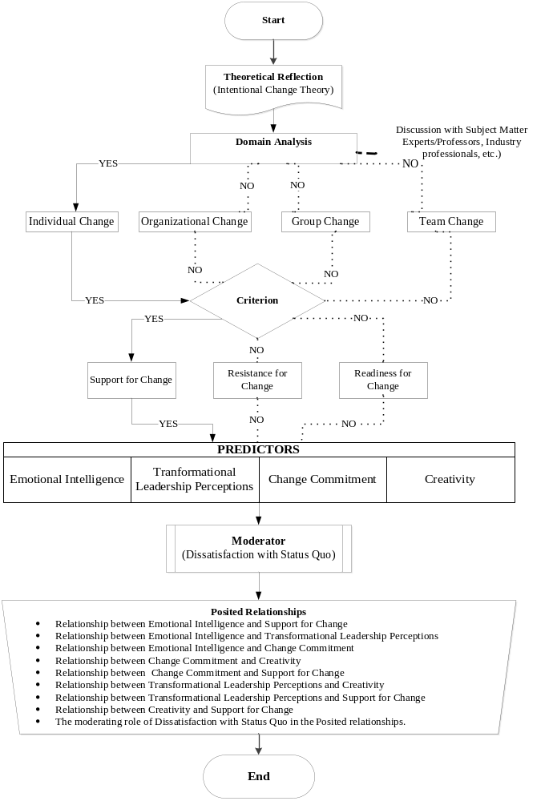

* Included processes are shown by arrows where as those not included are shown by dotted lines.

Table 2

Sample Characteristics

Demographic variables | Sample I (Students) |  |  |  |  |  | Sample II (Field)
Demographic variables | Whole Sample |  | High DSQ |  | Low DSQ |  | Whole sample |  | High DSQ |  | Low DSQ
Demographic variables | N=350 |  | N=160 |  | N=190 |  | N=507 |  | N=277 |  | N=230
Demographic variables | f | % | f | % | f | % | f | % | f | % | f | %
Gender
Male | 199 | 59.6 | 95 | 59.4 | 104 | 54.7 | 391 | 77.1 | 216 | 78.0 | 175 | 76.1
Female | 150 | 42.9 | 64 | 40.0 | 86 | 45.3 | 116 | 22.9 | 61 | 22.0 | 55 | 23.9
Age (Years)
18 – 25 | 326 | 93.1 | 149 | 93.1 | 177 | 93.2 | 195 | 38.5 | 100 | 36.1 | 95 | 41.3
26 – 35 | 21 | 6.0 | 10 | 6.2 | 11 | 5.8 | 205 | 40.4 | 122 | 44.0 | 83 | 36.1
36 – 45 | 1 | 0.3 | 1 | 0.6 | - | - | 96 | 18.9 | 48 | 17.3 | 48 | 20.9
46 and up | 2 | 0.6 | - | - | 2 | 1.1 | 11 | 2.2 | 7 | 2.5 | 4 | 1.7
Marital Status
Married | 43 | 12.3 | 18 | 11.2 | 25 | 13.2 | 267 | 52.7 | 151 | 54.5 | 116 | 50.4
Un Married | 307 | 87.7 | 142 | 88.8 | 165 | 86.8 | 240 | 47.3 | 126 | 45.5 | 114 | 49.6
Experience(Years)
5 or less | - | - | - | - | - | - | 293 | 57.8 | 158 | 57.0 | 135 | 58.7
6-10 | - | - | - | - | - | - | 148 | 29.2 | 80 | 28.9 | 68 | 29.6
11-20 | - | - | - | - | - | - | 60 | 11.8 | 36 | 13.0 | 24 | 10.4
21 or above | - | - | - | - | - | - | 6 | 1.2 | 3 | 1.1 | 3 | 1.3
Education
Graduation | - | - | - | - | - | - | 280 | 55.2 | 141 | 50.9 | 139 | 60.4
Masters | - | - | - | - | - | - | 206 | 40.6 | 123 | 44.4 | 83 | 36.1
M-Phil | - | - | - | - | - | - | 18 | 3.6 | 12 | 4.3 | 6 | 2.6
PhD | - | - | - | - | - | - | 2 | 0.4 | - | - | 2 | 0.9

REFERENCES

Adams, J. S. (1963). Toward an understanding of inequity. Journal of Abnormal Social Psychology, 67(5), 422-436.
Aiken, L. S. & West, S. G. (1991). Multiple regression: Testing and interpreting interactions. Thousand Oaks, CA: Sage Publications.
Akaike, H. (1987). Factor analysis and AIC. Psychometrika, 52(3), 317-332.
Akrivou, K., Boyatzis, R. E., & McLeod, P. L. (2006). The evolving group: Towards a
prescriptive theory of intentional group development. The Journal of Management Development, 25(7), 689-706.

